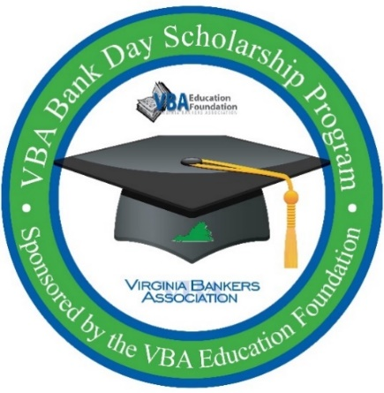
ATTENTION SENIORS:
OPPORTUNITY TO WIN
$7,500 SCHOLARSHIP

Virginia Bankers Association
Bank Day Scholarship program

Have you always wanted to learn more about the banking industry? Do you need $7,500 to help pay for your college tuition? If so, consider participating in the 2023 Bank Day Scholarship Program!

During this program, you will learn about the banking industry, ways to manage your financial future, careers in banking and the ways banks support the communities they serve. You will have access to a resource website that houses videos, articles and podcasts to explore and research. You will also be connected with a host bank that will provide support during the program. You will write an essay based on what you’ve learned and these essays will be judged by bankers from across the Commonwealth. Thirteen scholarships (six honorable mention, six regional and one statewide) will be awarded to the winners. Bank Day will take place in March 2023.

Scholarship Amounts:
$1,000 Each for six honorable mention scholarships
$2,500 Each for six regional winners
$5,000 Statewide winner ($7,500 total since all candidates will also be regional winners)

Participation Criteria:
- Currently enrolled as a high school senior in a Virginia high school
- Cumulative GPA of 3.0 or higher
- Resident of Virginia
- Teacher/guidance counselor contact information provided by student

2023 Deadlines & Important Dates:
March 3: Deadline to sign-up for the program.
March 13-31: Bank Day window – students have access to Bank Day resource website and engage with host bank.
March 21: PCB will host students in person for shadowing experience at 57 S. Main St, Harrisonburg.
March 31: Student essays are due by 5 p.m. Essays submitted directly to VBA via email.
Late April: Regional and honorable mention winners notified. Regional winners will be entered into the statewide contest for an additional scholarship.
Early May: State runner-up and state winners notified.

Interested students must register by March 3, 2023 online here:
https://www.formpl.us/form/5373805918814208
Questions? Contact Monica mcdearmon, vba manager, communications & financial education, at mmcdearmon@vabankers.org.

